TASKS
TASK 01 | Plan Your Identity Structure | 2 marks

Deployment plan
Naming conventions: I will use an initial.lastname@domain.onmicrosoft.com format for email addresses. While a last name alone would often be sufficient, the first initial is added to help distinguish users who share the same surname.
Group design:
- Development: Microsoft 365 Groups – these support collaboration and provide access to resources such as SharePoint sites.
- Operations: Security Groups – these are used to grant access to resources like SharePoint sites.
- Finance: Microsoft 365 Groups – these support collaboration and provide access to resources such as SharePoint sites.
Principle of least privilege: This is an RBAC (Role-Based Access Control) approach that ensures users are given only the minimum permissions required to perform their tasks, and no more.
TASK 02 | Create Users and Groups in Entra ID | 3 marks

2a
Finance:
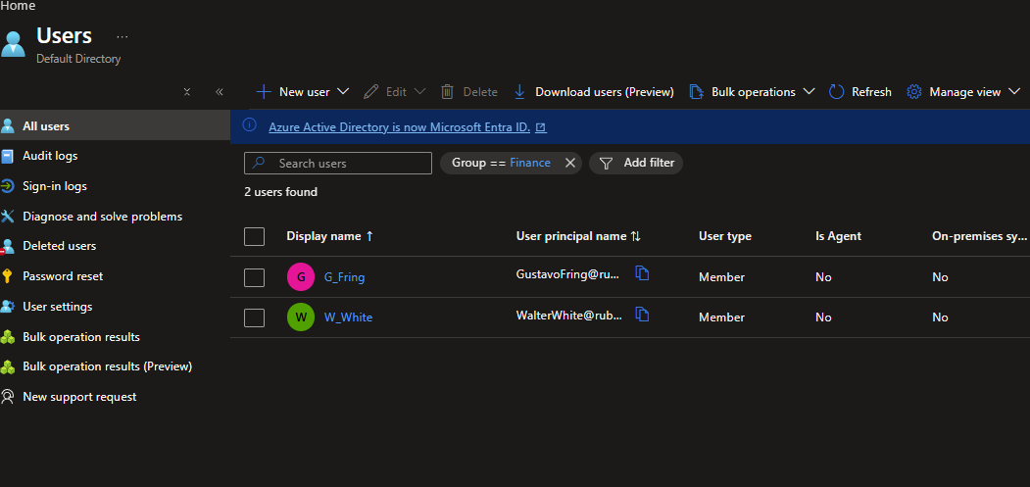
Development:
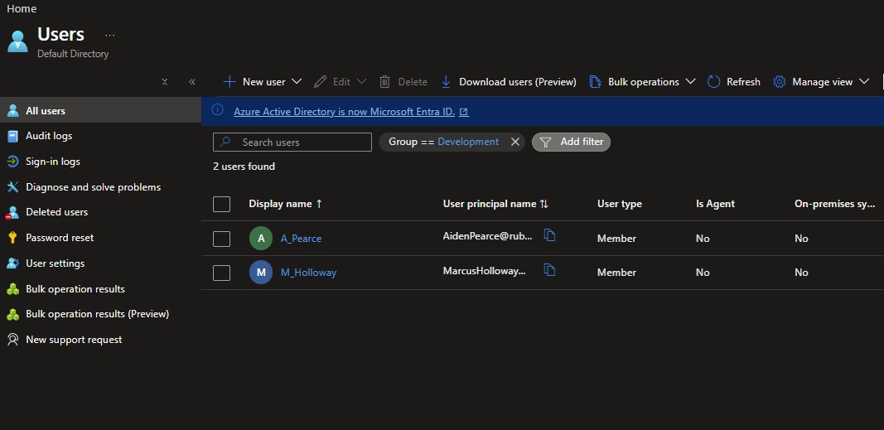
Operations:
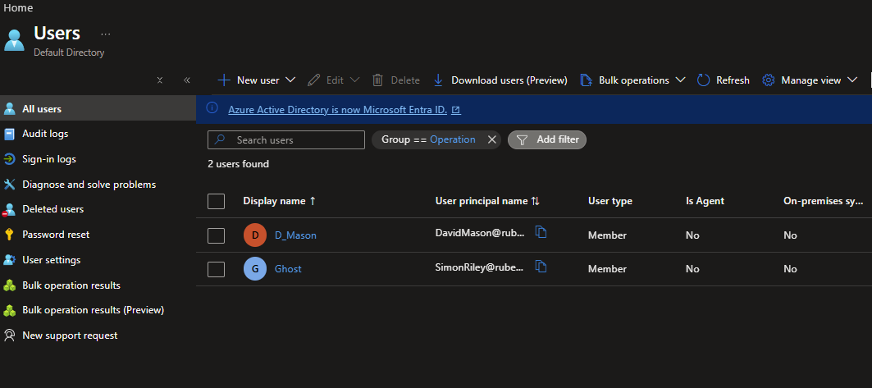
2b:
Development:
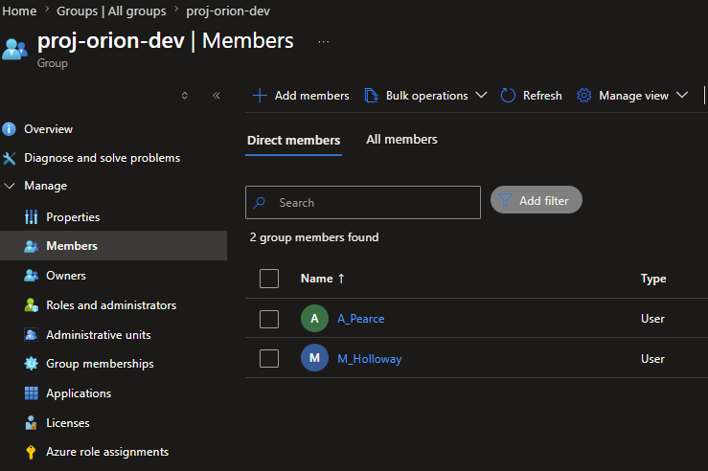
Finance:
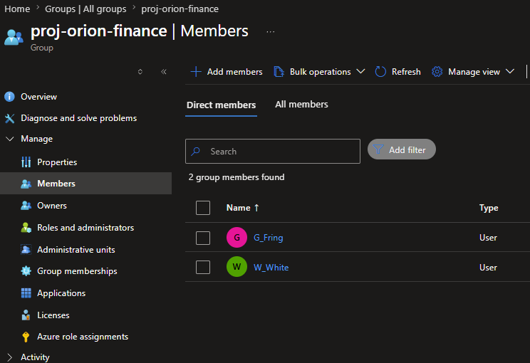
Operation:
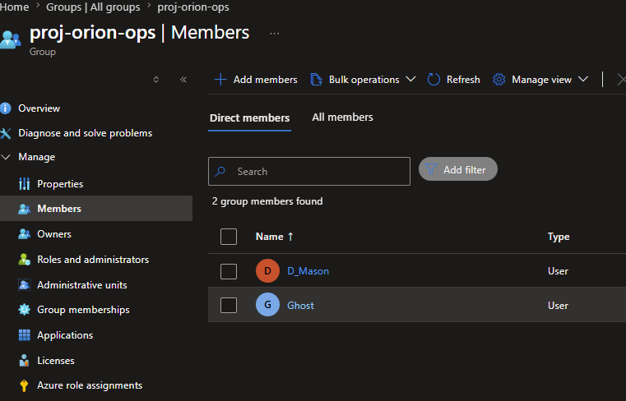
All groups will use assigned (static) membership. This ensures that users are only granted access to the groups corresponding to their respective department and responsibilities.
However, in larger organizations where individuals frequently work across multiple departments, dynamic membership may be more appropriate.
TASK 03 | Assign Initial Roles | 2 marks

